COMSAT UNIVERSITY ISLAMABAD

ABBOTTABAD CAMPUS

“Object Oriented Software Engineering”

**Semester Project Proposal**

*“Attendance Management System”*

***Group Members***

***Shahzaib***

*FA21-BSE-034*

***Ahsan Zeb***

*FA21-BSE-071*

***Shamsa Rani***

*FA21-BSE-145*

***Aqsa Sardar***

*FA21-BSE-079*

**Submitted to:**

*Sir Mukhtiar Zamin*

Table of Contents

CHAPTER 1 PROJECT PROPOSAL 5

Introduction 5

PROJECT OVERVIEW 5

1.2 PROBLEM STATMENT 5

OBJECTIVES 5

Vision and Business Case 5

Use-Case Model 6

Supplementary Specification 6

Glossary 7

Risk List & Risk Management Plan 7

Chapter-2 9

Use Case Distribution Table 9

Use case Diagram. 10

Shahzaib: 11

Brief level use case 11

Mark attendance 11

Search student 11

Check class 11

Shamsa 11

Brief level use case 11

View attendance 11

Communicate with teacher 12

Update information 12

Aqsa 13

Edit profile 13

Login 13

Notify 13

Ahsan 13

Logout 13

Generate discipline report 13

Manage settings 14

FULLY DRESSED USE CASES 14

Shahzaib: 14

mark attendance 14

Search student 16

CHECK CLASS 18

Shamsa: 19

Fully dressed use case: 19

View attendance 19

UPDATE INFORMATION: 21

AQSA: 22

EDIT PROFILE: 22

LOGIN: 23

NOTIFY: 24

AHSAN: 25

Generate discipline report 25

Manage settings: 26

Logout: 26

Prototypes 28

CHAPTER 3: DOMAIN MODEL 31

Domain Model 31

CHAPTER 4: SYSTEM SEQUENCE DIAGRAM (SSD) 32

Shahzaib (FA21-BSE-034) 32

Mark Attendance 32

Search Student 33

Check Class 34

Check Attendance 35

Shamsa (FA21-BSE-145) 36

View Attendance 36

Communicate with Teacher 37

Update Information 38

Ahsan Zeb (FA21-BSE-071) 38

Logout 38

Generate Discipline Report 39

Manage Settings 40

Aqsa Sardar (FA21-BSE-079) 41

Login 41

Edit Profile 42

Notify 43

Chapter 5 Operational Contract 44

Shamsa Rani 44

View Attendance 44

Communicate with teacher 45

Update Information 46

Shahzaib 48

Mark Attendance 48

Search Student 48

Check Attendance 49

Check class 49

Aqsa (FA21-BSE-079) 50

LOGIN 50

NOTIFY 52

Edit Profile 53

Ahsan Zeb (FA21-BSE-071) 56

Logout 56

Generate Discipline Report 56

Manage settings 58

CHAPTER: 6 59

PACKAGE DIAGRAM 59

# CHAPTER 1 PROJECT PROPOSAL

## Introduction

### PROJECT OVERVIEW

The Attendance Management System is a software developed for daily student attendance in university. It facilitates to access the attendance information of a particular student in a particular class. The information is sorted by the operators, which will be provided by the teacher for a particular class. This system will also help in evaluating attendance eligibility criteria of a student.

### 1.2 PROBLEM STATMENT

Attendance management has always been a challenge for colleges, with traditional methods like manual registers proving to be inefficient and time-consuming. An Attendance Management System can automate the process, making it easier and more accurate. The main aim of proposed system is to maintain attendance record of the students for a university. This will eliminate the need for manual registers and reduce the possibility of proxy attendance.

ATTENDENCE MANAGEMENT SYSTEM (AMS) has four user modules to run the system i.e., Admin, Staff, Student and Guardian. Initially the system will be blank, The Administrator has a right to create standard and classroom for school and same time he has to add staff detail. Administrator generates unique username and password for all staff while adding staff detail. All staff maintain attendance of student, generate reports month wise, date wise. Guardian will be able to view their children’s attendance and Contact with relevant staff members.

### OBJECTIVES

* To make it easier and faster for administration to keep track of student’s attendance.
* To maintain a secure and proper attendance report of students.
* To build a connection between guardians and teachers.

### Vision and Business Case

An attendance management system (AMS) is a software solution that educational institutes to efficiently track and manage student attendance, absenteeism, and leave requests. The vision for an AMS is to provide a centralized system for managing student attendance data, reducing manual data entry, and providing real-time visibility into attendance trends and patterns.

The business case for an AMS includes several benefits for institutes, including:

* **Improved Efficiency:** An AMS can significantly reduce the time and effort required to manage attendance data, freeing up administration personnel to focus on more strategic activities.
* **Increased Accuracy:** An automated system can eliminate errors associated with manual data entry, ensuring that attendance data is accurate and up to date.
* **Enhanced Student/Guardian Engagement:** By providing employees with self-service access to their attendance data and staying in touch with guardians of students, an AMS can increase transparency and trust between students, guardians and administration.
* **Cost Savings:** An AMS can help organizations reduce the cost of manual attendance tracking, such as paper-based timesheets and manual data entry, as well as minimize the risk of costly compliance violations.

### Use-Case Model

* **Student Attendance Tracking:** This use case involves students using the system to mark their attendance, either through a web-based interface or a mobile application. The system records the attendance data and provides real-time reporting to faculty and administration.
* **Attendance Analytics:** This use case involves faculty and administration using the system to analyse attendance data and identify trends, such as low attendance rates or frequent absences. The system may also provide insights into student engagement and academic performance.
* **Leave Management:** This use case involves students using the system to request time off for reasons such as illness, family emergencies, or academic competitions. The system routes the requests to the appropriate authority for approval and records the time off in the attendance database.
* **Compliance Reporting:** This use case involves the system generating reports that demonstrate compliance with regulations, such as the University Grants Commission (UGC) guidelines and accreditation requirements.
* **Notifications and Alerts:** This use case involves the system sending notifications and alerts to students and faculty regarding attendance requirements, upcoming events, and important deadlines.
* **Security and Access Control:** This use case involves the system providing secure access to attendance data, ensuring that only authorized personnel can view or modify the data.

### Supplementary Specification

Here are some possible supplementary specifications for Attendance Management System:

* **User Roles:** The system should provide different user roles with varying levels of access and permission. For example, students may only have permission to mark their attendance and view their records, Guardians would be able to look up to their children’s attendance report while faculty and administration may have permission to view and modify attendance records for all students.
* **Integration with Student Information System (SIS):** The system should integrate with the university's SIS to access student information, such as course enrolment and class schedules, to ensure accurate tracking of attendance.
* **Attendance Policies:** The system should allow the university to define and enforce attendance policies, such as minimum attendance requirements, late arrival policies, and penalties for non-compliance.
* **Attendance Reports:** The system should provide a range of reports to help faculty and administration analyse attendance data and identify trends, such as daily/weekly/monthly attendance reports, absenteeism reports, and class-wise attendance reports.
* **Mobile Application:** The system should have a mobile application that allows students to mark their attendance, view their records, and request time off from their mobile devices.
* **Web Based Interface:** The system should have a website that allow students, guardian and staff to view attendance records, and perform other relevant actions.
* **Notifications and Alerts:** The system should send notifications and alerts to students and faculty regarding attendance requirements, upcoming events, and important deadlines.
* **Data Security:** The system should ensure that attendance data is secure, with access restricted to authorized personnel only. The system should also comply with data privacy laws and regulations.
* **Technical Requirements:** The system should specify technical requirements such as hardware, software, and network infrastructure, necessary to run the system efficiently and effectively.
* **Support and Maintenance:** The system should provide ongoing support and maintenance to ensure that the system is up-to-date, and any issues or bugs are addressed promptly.

### Glossary

* **AMS:** Attendance Management System.
* **SIS:** Student Information System.

### Risk List & Risk Management Plan

Here are some possible risks that may be associated with Attendance Management System, along with a risk management plan to address each risk:

* **User Error:** The risk that teachers may make mistakes when using the system, such as marking incorrect attendance or entering incorrect data. The risk management plan includes user training and education, user-friendly interfaces, and automated data validation to minimize this risk.
* **Developer’s Negligence:**

When a team of developers work on a project, they may design different style or type of models for a single entity. This leads to confusion for both the user and developers. The risk management plan will keenly look into such matters and correct them right on spot to avoid any future errors or faults in the system.

* **Non-compliance:** The risk that the system may not comply with legal or regulatory requirements, such as data privacy laws or accreditation requirements. The risk management plan includes regular compliance audits and reviews and updating the system to meet any new legal or regulatory requirements.
* **Poor User Adoption:** The risk that students or faculty may not fully adopt the system, resulting in incomplete or inaccurate attendance data. The risk management plan may include user training and education, and ongoing communication and support to ensure that users understand the benefits of the system and how to use it effectively.
* **4. Negligence**: When data is stored in computers or laptops, it has become so natural that people lose the information when files are accidentally deleted or even it could fall into the wrong hands. Ensure a proper backup strategy to keep your data on important devices and run them smoothly without hassles.
* **Unsafe data:** If adequate safety precautions are not taken when files and documents are shared in website, smartphones and tablets via internet networks, the information contained on them might gain access to the devices and get exposed to risks. We can make use of cloud deployments to manage the education system better and better.

# Chapter-2

## Use Case Distribution Table

|  |  |  |
| --- | --- | --- |
| **Sr#** | **Group Members** | **Assigned use cases** |
| 1 | FA21-BSE-034 | 1. Mark Attendance 2. Search Student 3. Check Attendance 4. Check Class |
| 2 | FA21-BSE-145 | 1. View Attendance 2. Communicate with Teacher 3. Update Information |
| 3 | FA21-BSE-079 | 1. Edit Profile 2. Login 3. Notify |
| 4 | FA21-BSE-071 | 1. Logout 2. Generate Discipline Report 3. Manage Settings |

## Use case Diagram.

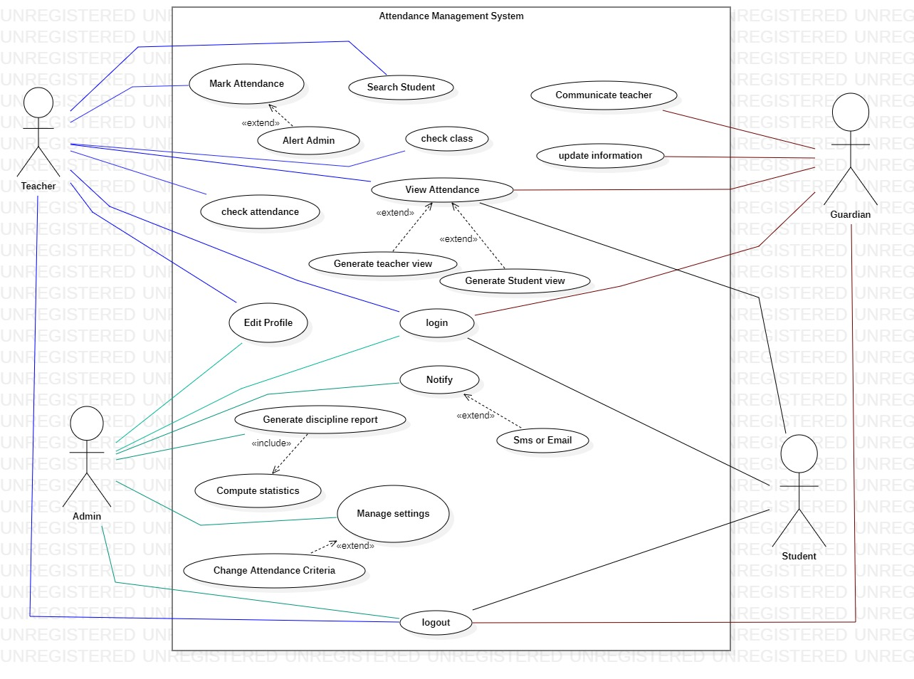

# Shahzaib:

## Brief level use case

### Mark attendance

This use case starts when teacher enters the class and needs to mark attendance of students. System will display login screen where teacher enters their credentials such as name and password to login to system. Upon successfully login system enables teacher to choose particular class and section of which the attendance is to be marked. After selecting the particular class teacher will mark present, if student attends class or absent otherwise. System also allow teacher to change the marked attendance. In case of late appearance of student in class it will totally depends upon teacher whether he/she wants to mark absent or present.

### Search student

This use case will start when teacher or admin wants to search the attendance record about a particular student from the attendance management system. System allows the teacher/admin to enter name or registration no. of particular student and then system retrieve and display the relevant information. If user had entered wrong name or reg no system will display error message and prompt user to enter the correct information.

### Check class

This use case starts when teacher enters the class room and needs to mark attendance of that class. First of all teacher will login to AMS (attendance management system ) by entering their credentials such as name and password. After logging in teacher has to check the class of which he/she have to mark attendance. System will allow teacher to enter name of that particular class and also select their sub section to mark attendance.

# Shamsa

## Brief level use case

### View attendance

The user enters their specific login information, usually their ID and password, to access the attendance management system. System will verify the users credentials if the credentials are valid system will successfully login and display the dashboard of AMS according to user’s role (admin, teacher, guardian and student).

**Student view:**

The system shows the student's attendance history for each class period, indicating whether they were Present or absent. The student has the option to see their attendance records for a single class and even see in which lecture they were absent.

**Guardian view:**

The system shows the attendance records of their child for all classes, indicating whether they were Present or absent. The guardian can see the attendance data for their child for a given class period or for month or semester. In addition, the guardian has access to information about attendance trends and patterns for their child, such as average attendance rates and the number of absences and late arrivals. The system may send the guardian notifications or alerts if their child’s attendance is below then 80%.

**Teacher & Admin view:**

The system displays the attendance records of all students in their classes, indicating whether they were Present or absent. The admin or teacher can view the attendance data for specific class session or for a particular class period or for month or semester.

The administrator can also create attendance reports for the institution that display attendance patterns and trends, such as the average attendance rate of absences in  various departments and classes. The system's access permissions, user accounts, settings, and parameters can all be controlled by the administrator.

### Communicate with teacher

* This use case will begin when the student has a history of frequent absenteeism, the guardian might be concerned or wonder about it. By sending messages through the system, the guardian can contact their Childs teacher about attendance concerns. The parent can read the teachers' responses in the system and, if necessary, carry on the conversation.
* The teacher can reply to the parent's messages through the system, offering explanations or suggestions for how to fix the attendance problems.
* The administrator may see the communications between the teachers and parents, ensuring that they are acceptable and productive.

### Update information

This use case will begin when user login to AMS by entering their credentials.

* If guardian wants to update their information system enables the guardian to modify personal data, including contact information, emergency contacts, etc. The guardian may also modify their child’s personal data, including address, phone number, and medical history. The system saves the changed data, making it accessible to the administration and the student's teacher.
* The system allows the administrator to access and update the personal information of guardians and their children. The administrator can add or remove guardians, as well as update their contact details or emergency contact information. The administrator can also update the personal information of students, such as address, phone number, medical information, etc. The updated information is saved in the system and is available for access by the guardians and the student's teacher.

# Aqsa

### Edit profile

This use case begins when the user enters their specific login information, usually their ID and password, to access the attendance management system. When user wants to edit their profile, they select the edit profile option system will display the users profile information, including name contact details or any other relevant information. The user can change their name, email, phone number, and address on their profile. The user has the option of updating their password or adding a profile picture. The user can save the modified profile information after making changes.

### Login

* The user opens the attendance management system on their device and navigates to the login bar. Then user enters their credentials such as name and password. System verifies the credentials and grant access to appropriate features and information. The system displays an error notice and asks the user to try again or change their password if their login credentials are incorrect.
* The system will send an email with instructions on how to reset the password if the user requests a password reset because they have forgotten their password.

### Notify

This use case will begin when attendance of student is below than 80% i.e the criteria set by institution. Admin/teacher will notify guardian of student whose attendance is below 80% if actions are not made by guardian, then teacher will alert them that particular student cannot appears in exam if their attendance is below 80%.

# Ahsan

### Logout

This use case begins when user is currently logged in to the AMS and wishes to logout from the attendance management system. User navigates to the logout button and clicks it. AMS detects that user initiate logout process then system logged the user out of system and redirects the user to login page and system clears the user’s session.

### Generate discipline report

The administrator accesses the attendance management system by entering their credentials such as name and password. The administrator visits the page where the discipline report is generated. The administrator decides on the report's date range and any additional important filters, including grade level based on the chosen criteria, the system generates the discipline report and presents it on the screen. The report is shown on the screen by the system, and the administrator has the option to download or print it.

### Manage settings

The administrator accesses the attendance management system by entering their credentials such as name and password. After successfully logging in to the AMS system allows admin to navigate to settings page. System stores various settings that can be customized by admin so system allows admin to access and change these settings according to needs. The administrator can control a variety of system preferences such as

* Languages preferences
* Time and date format
* Options for notifications
* security parameters
* user roles and permission
* change attendance criteria

Admin can customize these settings according to need of organization and then save it.

# FULLY DRESSED USE CASES

## Shahzaib:

### mark attendance

* **Scope:** University attendance system
* **Level:** User goal
* **Primary actor:** Teacher
* **Stakeholders** and interests
* **Teacher**

Teacher is responsible of marking students of selected class to ensure accuracy of attendance record.

* **Student**

Attends class and keeping track of their attendance percentage

* **Guardian**

Monitors their child’s academic progress and ensure their regular attendance percentage

* **Pre-conditions**

The mechanism for tracking attendance is accessible by the teacher. The method for tracking attendance is working properly.

* **Post conditions**

The attendance management system has been updated with the attendance marks. Updates have been made to the student's attendance record.

* **Main success scenario**
* User logs in to the AMS with their authorized credentials.
* User select particular class for whom they want to mark attendance for.
* AMS retrieve the list of student enrolled in that particular class. A list of students enrolled in the given class and date is shown by the system, and any modifications made by the teacher are updated in real-time.
* User then mark attendance of each student present or absent manually.
* AMS update attendance in real time.
* **Extensions**
* The teacher won't be able to record attendance manually if the attendance management system is down or has technical issues.
* The teacher won't be able to manually mark attendance if they don't have permission to have access to the attendance management system.
* The teacher can use a different device to access the system or get help from the system administrator if they run into technical issues when recording attendance.
* The database will be updated to reflect the changes if a student's attendance status changes after it has been noted, and the teacher can update the attendance status in the system.
* The teacher can visit the system at a later time and register attendance later if they neglect to mark attendance for a certain time or date.
* **Special requirements**
* Text must be visible from 1 meter
* When user enters its credentials verification response is within 20 sec 90% of the time.
* The interface of the system should be straightforward and easy to grasp.
* Marking attendance of students should be easy and fast.
* As required by the system, the typography is treated with extreme strictness.
* **Technology and data variation list**

**Internet access:**

The university attendance system should be able to accommodate fluctuations in internet access, such as slow connectivity, for both teachers and students.

**Various data:**

Privacy options: To prevent the release of student attendance records to unauthorized parties or entities, the university attendance system should have privacy settings.

**Course schedules**:

Variations in course schedules, such as changed class times or cancellations due to any situation, should be supported by the university attendance system.

**Student information:**

The university attendance system ought to be able to accommodate changes.

* **Open issues**

**• Attendance rules and policies:**

At the university, different departments and courses may have different attendance rules and practices. To account for these changes while maintaining consistency in data collecting and reporting, the attendance system should be designed.

**• Data accuracy:**

It's critical to make sure that the university attendance system is collecting correct and current attendance information. For students’ inaccurate attendance records can have detrimental effects, such as hurting grades or causing administrative problems. To ensure correctness, the system should undergo routine audits and updates.

**• User interface design:**

The university attendance system's user interface, including the "Mark Attendance" capability, should be simple and easy to use.

### Search student

* **Use case**: search student
* **Scope:** university attendance system
* **Level:** user goal
* **Primary actors:** teacher
* **Stake holders and interest1;**
* **Teacher**

A teacher can search for specific student’s attendance record quickly and easily.

* **Students**

They want to ensure that their attendance is recorded properly and can be accessed by their professor.

* **Administration**

They want to maintain accurate attendance records for academic and administrative purpose.

* **Preconditions:**

User has appropriate login credentials and has access to the course and list of students enrolled in the course.

* **Post conditions:**

The attendance record of searched student is accurately displayed in AMS.

* **Main Success Scenario:**
* Using their login information, the teacher logs into the attendance management system.
* The teacher uses the system's search students feature to find the desired student.
* The user enters the student's name or ID number to do a search for them.
* A list of students who fit the search criteria is shown by the system.
* The teacher chooses the student from the list of search results that they were looking for.
* The system shows the student's attendance history for the chosen window of time or calendar range.
* Based on the information given, the teacher can inspect the attendance records and take any necessary actions.
* **Extensions;**
* The user may have provided inaccurate information or the student's record may not exist in the system if a search yields no results. If this occurs, the system may prompt the user to double-check the spelling or ID number and, if necessary, offer guidance on how to add a new student to the database.
* The system can include advanced search options to help the user focus their search if they need to look for students based on specific criteria, including grade level or course enrollment.
* The system may provide an edit or update feature within the student's record if the user needs to make changes to the attendance data for a particular student.
* The system can offer analytics or reports if the user wants to check attendance statistics or create reports for a particular student or group of students.
* **Special requirements:**
* By name, student ID, class, or any other relevant information that can help identify the student, users should be able to find students using the search tool.
* The display of all records should allow them to select the appropriate student.
* The search results should be provided in a clear and concise manner with important information, such as the student's name, ID, and class, to make it simpler for the user to identify the correct student.
* The search function must be protected so that only authorized users can look for student information.

### CHECK CLASS

* **Use case:** check class
* **Scope:** university attendance system
* **Level**: user goal
* **Primary actors:** teacher
* **Stake holders and interest**
* **Teacher:**

Teacher wants to mark attendance of students therefore teacher check the class and section so they are able to take attendance quickly and easily, and having accurate attendance record for their classes.

* **Admin:**

Admin has an interest in ensuring that attendance record is being kept accurately and any issue with attendance can be addressed in timely manner.

* **Pre-conditions:**

User must have proper access to AMS and class must be registered in AMS.

* **Post-conditions:**

User has successfully selected the class and particular section of which attendance is to be marked. And the attendance record of selected class has been displayed.

* **Main Success Scenario:**

|  |  |
| --- | --- |
| **User** | **System** |
| User login to AMS | System verifies credentials and open dashboard. |
| User navigates to check class function and click it. | System presents list of classes registered in system. |
| User selects / search their required class | System successfully shows attendance page of that class. |

* **Extension:**

|  |  |
| --- | --- |
| **User** | **System** |
| User selects class whose attendance record does not exist | System will display error message indicating that no attendance records are available for this class |

* Special requirement:

User should be given options for class to select so they don’t have to write full name and then section of that class and saves time.

# Shamsa:

## Fully dressed use case:

### View attendance

* **Use case:** view attendance
* **Scope:** University attendance system
* **Level**: User goal
* **Primary actor:** student, guardian
* **Stakeholders and interests**
* **Teacher:** Needs a quick and easy way to view student attendance records for a specific course and spot attendance patterns and trends.
* **Students:** want information about their attendance status and progress as well as reliable and easily available attendance records.
* **Administration:** Wants to make sure that attendance rules and policies are followed, as well as to maintain precise attendance records for auditing purposes.
* **Preconditions**

To access the system, actors must have valid login credentials. There must have been an earlier creation and storage of attendance data in the system.

* **Post condition**

To keep track of the actor's actions, the system refreshes the access log. The system is still in a position where other actors can access attendance information.

* **Main success scenario**
* Actor enters their login information into the attendance tracking system.
* Actor chooses from the system menu's "View Attendance" option.
* A list of the students connected to the actor's account is shown by the system.
* To view a student's attendance history, the actor chooses a name from the list.
* The actor sees the attendance history that the system has pulled up for the chosen student.
* Depending on the options the system offers, the actor can examine the student's attendance record for a specific day, week, month, or semester.
* Additionally, the actor can see information on any excused absences or tardiness for the chosen time frame.
* If the actor is a teacher, they can also, if necessary, edit the selected student's attendance record.
* The actor may log out of the system once they viewed attendance.
* **Extension**
* The system will display an error warning and direct the user to get in touch with the system administrator if the actor's account is empty of any students.
* The system will prompt the actor to try again with a valid student if they choose a student that doesn't already exist in the database.
* The actor might ask the system admin for help if they run into any technical difficulties when viewing attendance records.

1. Communicate with teacher:

* **Use case:** communicate with teacher
* **Scope:** University attendance system
* **Level**: User goal
* **Primary actor:** teacher, guardian, admin.
* **Stakeholders and interests:**

Guardian wants to monitors their child’s attendance and incase of more absenteeism they can contact with teacher try to solve problem.

* **Pre-conditions**

Guardian must login to AMS. They must have student enrolled in that course taught by that teacher.

Teacher must have provided mean of communication for guardian such as phone no, email address or messaging platform.

* **Post-conditions**

Guardian received response from teacher and their communication is stored for future reference.

* **Main Success Scenario:**

|  |  |
| --- | --- |
| **User** | **System** |
| User login to AMS | System verifies credentials and open dashboard. |
| User navigates to communicate with teacher button and click it. | System displays available means of communication for the teacher. |
| User selects desired mean of communication. | System prompt user to compose message to teacher. |
| User write message to teacher regarding students’ attendance. | System sends this message to teacher via selected means. |

* **Extensions:**

|  |  |
| --- | --- |
| **User** | **System** |
| User try to send empty message | System warns user that message field cannot be empty. |
| Communicate with teacher button is not available. | System displays error showing that teacher has not provided mean of communication. |

### UPDATE INFORMATION:

* **Use case:** update information
* **Scope:** University attendance system
* **Level**: User goal
* **Primary actor:** guardian, admin
* **Stakeholders and interests**
* **Admin:**

Admin has primary interest in maintaining accurate and up to date information of student for administrative purpose.

* **Teacher:**

Teacher has interest in accessing accurate information for academic purpose.

* **Guardian:**

Guardian has interest that their child’s information is accurate and up to date.

* **Pre-conditions**

User must login to AMS and has appropriate permission to update information.

* **Post-condition**

Updated information is saved in AMS.

* **Main Success Scenario:**

|  |  |
| --- | --- |
| **User** | **System** |
| User selects update information option from system menu. | The system presents the use with a form to update relevant information such as name, password and contact details. |
| User update the information as required | System saves the updated information to AMS and display confirmation message to user. |
| User confirm the changes | System saves updates successfully. |

* **Extensions:**

|  |  |
| --- | --- |
| **User** | **System** |
| User enters invalid information | System displays error message and prompt user to enter valid information. |
| User cancel the changes by click on cancel button | System discards the changes. |
| User does not have permission to update information | System displays message box showing you are unable to change information. |

* **Special requirements:**
* System should allow only authorized person such as admin and guardian to update information.
* System should have user friendly interface that is easy to navigate and use.

# AQSA:

### EDIT PROFILE:

* **Use case:** edit profile
* **Actors:** teacher/guardian/admin
* **Scope:** university attendance system
* **Level:** user goal
* **Stake holders and their interests:**
* **Teacher, admin, guardian**

They update their information in their profiles to maintain the correct record.

* **Pre-conditions**

The user must be logged in to the system used to track attendance. A user needs to have the required access in order to change their profile information.

* **Post-conditions**

The users profile information is updated in the system.

* **Main success scenario**
* To record attendance, a user logs into the system.
* User selects "View Attendance" from the system menu.
* A list of the students connected to the actor's account is shown by the system.
* To view a student's attendance history, the user chooses a name from the list.
* The user sees the chosen student's attendance history via the system.
* If necessary, teacher can alter the student's attendance history.
* Users can logout of system after viewing attendance.
* **Extensions**

The system will display an error message and ask the user to fix the mistakes before saving if the user tries to store incomplete or incorrect data.

* **Technology and data variation**
* Only permitted users must be able to change their profile information, hence the system must be sufficiently secure.
* Users should be able to upload and save their profile images using the system.
* Different user types should have varying degrees of access to the system. For instance, teachers could not have as much access as administrators.
* Users should be able to update their contact information in the system, including their phone number and email address.
* Users should be able to change their name, gender, date of birth, and other personal data through the system.
* In order to guarantee data correctness and integrity, the system should contain a feature to verify and validate changes to user profile information before saving.

### LOGIN:

* **Use case:** login
* **Actor:** admin, guardian, teacher, student
* **Scope:** university attendance system
* **Level:** user goal
* **Stake holders and interests:**
* **Admin:**

Wants to ensure that system remains secure and is maintained effectively.

* **Teacher:**

Teacher wants to mark attendance of students and kept proper record of it.

* **Guardian:**

Wants to monitor their child’s attendance record.

* **Student:**

Wants to monitor their own attendance and see which lecture they missed.

* **Pre-condition**
* User must have valid login credentials.
* The users account must be active and not deleted.
* **Post-condition**

User has login to the AMS and access their authorized functionality.

* **Main Success Scenario**

|  |  |
| --- | --- |
| **User** | **System** |
| User open AMS and wants to login | System displays empty fields with username and password. |
| User enters valid name and password. | System verifies given credentials and grant access if they are valid. System shows dashboard of AMS after successful verification. |

* **Extensions**

|  |  |
| --- | --- |
| **User** | **System** |
| User enters invalid name or password | System shows error message that you enter invalid name or password. |
| If users account is deleted | System displays error message and denies system access. |
| If user forgot their password | System sends code on their email to recover it. |

* **Special requirement**
* System should enforce strong password combination policies such as minimum length and combination of letter, symbol and number.
* System should assign different roles to user such as admin, teacher etc. according to their level of access and authority.

### NOTIFY:

* **Use case:** notify
* **Actor:** admin, AMS
* **Scope:** university attendance system
* **Level:** user goal
* **Stake holders and interests:**
* Admin

Admin wants to ensure that student’s attendance is above given criteria.

* Guardian

Needs to be informed about their student’s attendance and performance in class.

* **Pre-condition**

Students are registered in AMS and attendance criteria are set.

* **Post-condition**

Guardians are notified of the low attendance of their child.

* **Main Success Scenario**

|  |  |
| --- | --- |
| **User** | **System** |
| User monitors attendance % of students continuously | System shows percentage of attendance |
| User found the attendance of student below than set criteria that is 80% and generate warning message. | System requests to attach record of that student’s attendance also. |
| User attaches record also and send notification to guardian. | System sends this notification to guardian successfully. And record the notification information for future reference. |

* **Extensions**

|  |  |
| --- | --- |
| **User** | **System** |
| If guardian didn’t respond to notification or take any action. | System will generate warning message that your child is not eligible to appear in exams. |

# AHSAN:

### Generate discipline report

* **Use case:** generate discipline report
* **Actor:** admin
* **Scope:** university attendance system
* **Level:** user goal
* **Stake holders and interests:**
* **Admin**

The discipline report is mostly of interest to administrators because it aids in their monitoring and improvement of the institution's discipline.

* **Teacher**

Since they are in charge of upholding discipline in their classrooms, teachers are interested in the discipline report.

* **students**

Students should pay attention to the discipline report because it affects both their actions and academic performance.

* **Pre-conditions:**

The user must be logged in as an administrator to the attendance management system. The system must contain attendance records and information about disciplinary actions.

* **Main Success Scenario**
* The administrator goes to the attendance management system's "Discipline Report" area.
* When choosing the time period for which the discipline report should be generated, the administrator is prompted by the system.
* The administrator chooses and confirms the required time frame.
* The system obtains all attendance data and information about disciplinary actions for the chosen time frame.
* The sys creates a discipline report that contains the following details:
* Total number of students who received disciplinary action during that time and types of punishment used (such as detention, suspension).
* The system displays report and admin review it and take action accordingly
* **Extension:**

The system will display a notification indicating that no report can be generated if there are no attendance records or information regarding disciplinary actions.

* **Technology and data variation**
* To ensure that only authorized users may create disciplinary reports, the system should have proper safety systems in place.
* Administrators should be able to alter the report in order to include more information as necessary using the system.
* For further analysis or sharing, the system should include an option to export the disciplinary report in a variety of formats, such as PDF or CSV.
* The system needs to have an option to automatically flag particular actions or attendance patterns for further admin review.

### Manage settings:

* **Use case:** manage settings
* **Actor:** admin
* **Scope:** university attendance system
* **Level:** user goal
* **Stake holders and interests:**
* Admin wants to have full control over the AMS.
* **Pre-condition:**

Admin is logged in to the AMS.

* **Post-condition:**

System setting has been updated as per admin modification and admin has control over various setting of system.

* **Main Success Scenario**

|  |  |
| --- | --- |
| **User** | **System** |
| Admin selects manage settings option from the menu. | System shows settings page. |
| Admin can set or change various settings of system such as admin change the criteria of attendance to define minimum require attendance for student to appear in exams. | System saves the changes |

* **Extensions**

|  |  |
| --- | --- |
| **User** | **System** |
| If user tries to enter invalid attendance criteria. | System generates error message. |

### Logout:

* **Use case:** logout
* **Actor:** admin, teacher, guardian, student
* **Scope:** university attendance system
* **Level:** user goal
* **Stake holders and interests:**
* Admin, guardian, student, and teacher wants to safely logout from the system to ensure security.
* **Pre-conditions**

User must login to the AMS.

* **Post-conditions**

User is logout from the system and their session is terminated.

* **Main success scenario**

|  |  |
| --- | --- |
| **User** | **System** |
| User selects logout from AMS | System prompt user for confirmation message. |
| User confirms logout action. | System logout the user out of system and displays login page. |

* **Extensions**

|  |  |
| --- | --- |
| **User** | **System** |
| User accidently clicks the logout option | System shows confirmation message |

* **Special requirement**

User should have proper confirmation message to avoid accidental logout.

System should redirect the user to login page after logout.

# Prototypes

# CHAPTER 3: DOMAIN MODEL

## Domain Model

# CHAPTER 4: SYSTEM SEQUENCE DIAGRAM (SSD)

# Shahzaib (FA21-BSE-034)

### Mark Attendance

### Search Student

### Check Class

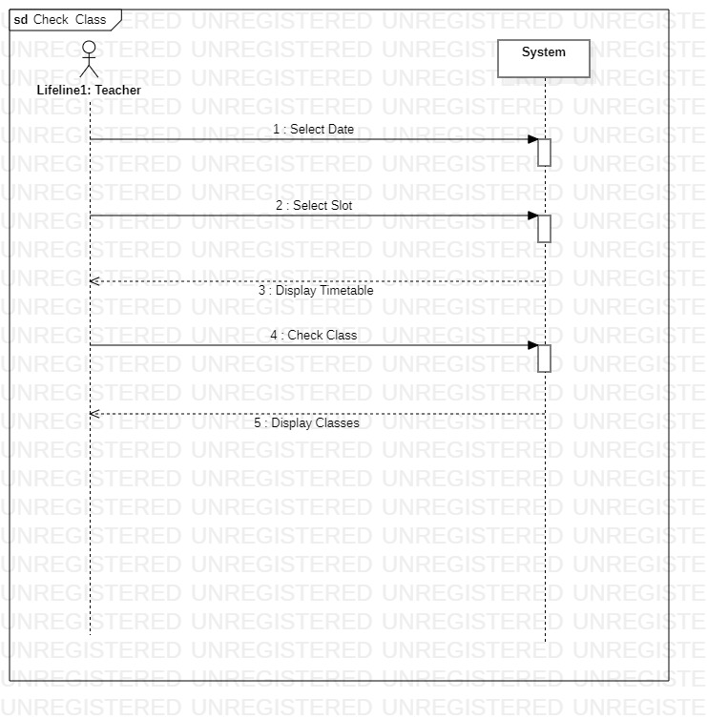

### Check Attendance

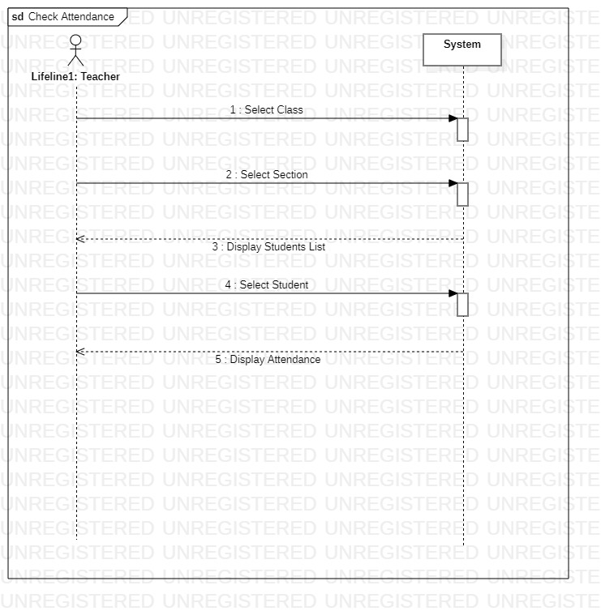

# Shamsa (FA21-BSE-145)

# View Attendance

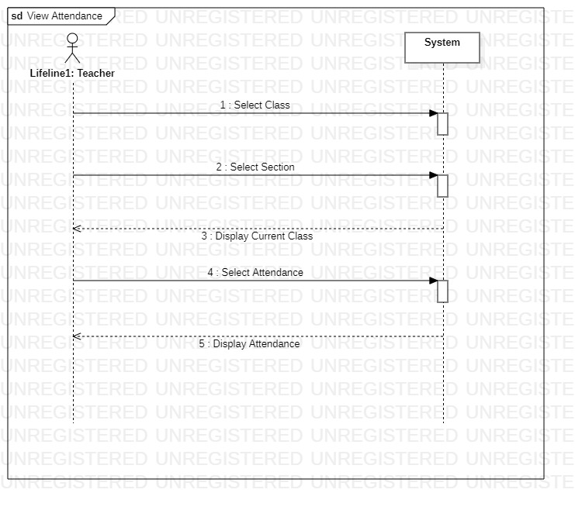

## Communicate with Teacher

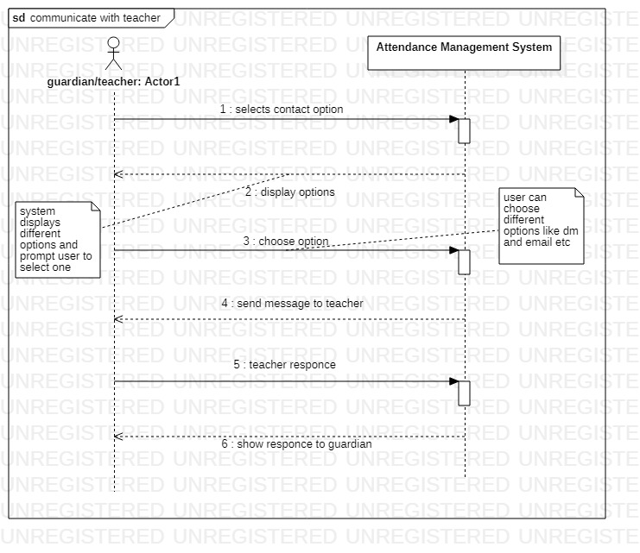

## Update Information

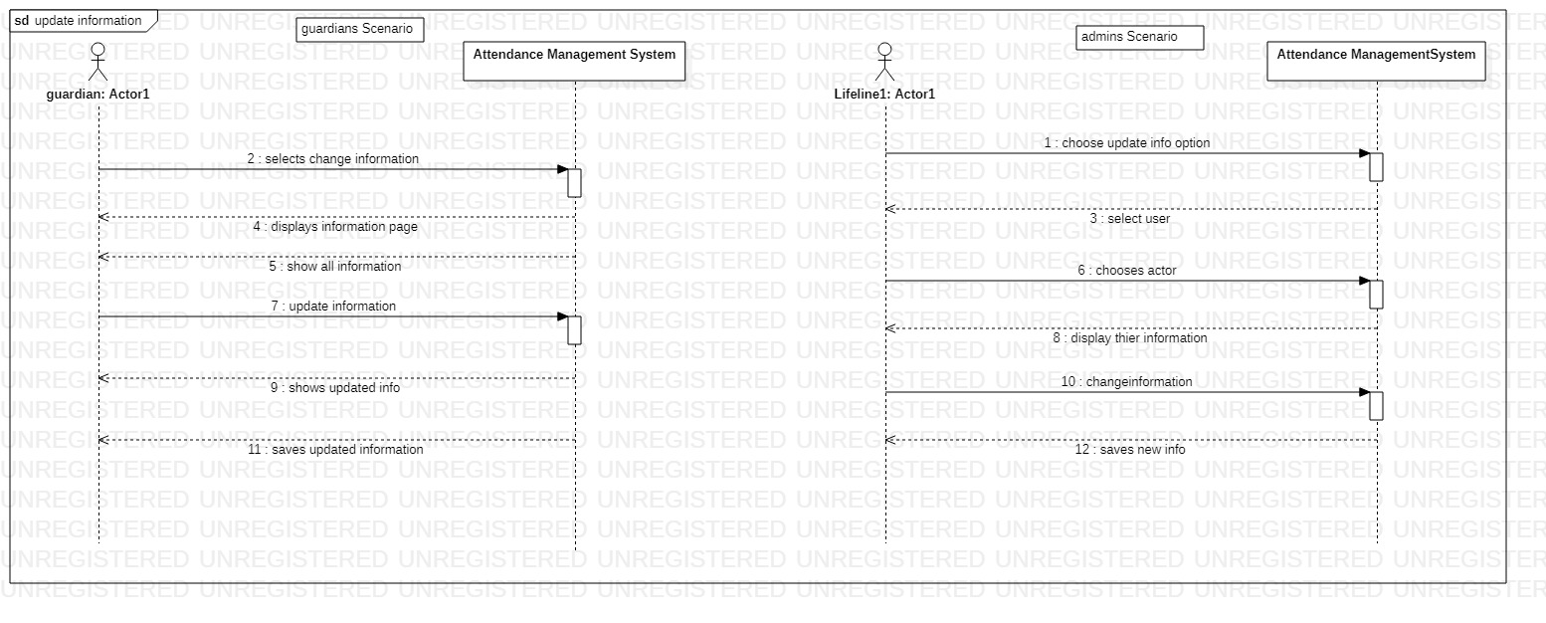

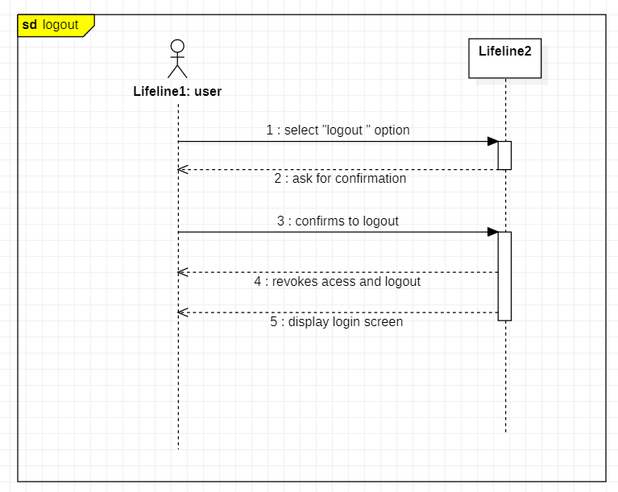

## Ahsan Zeb (FA21-BSE-071)

### Logout

### Generate Discipline Report

### Manage Settings

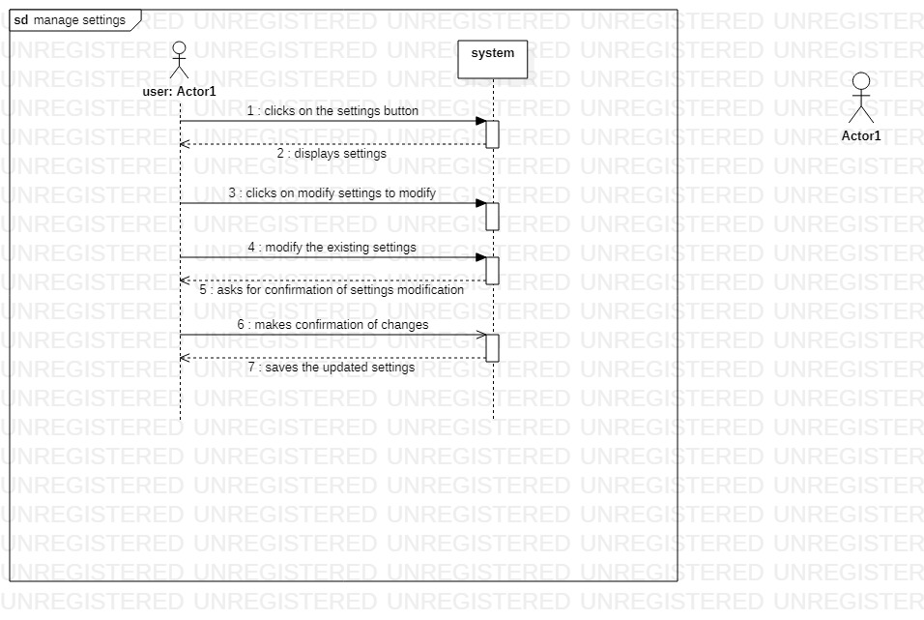

## Aqsa Sardar (FA21-BSE-079)

### Login

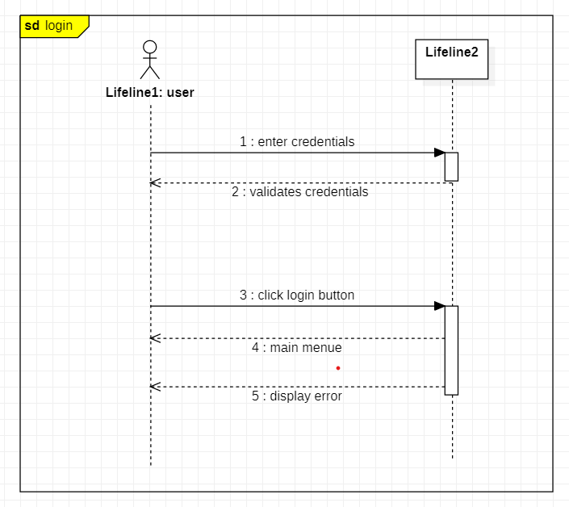

### Edit Profile

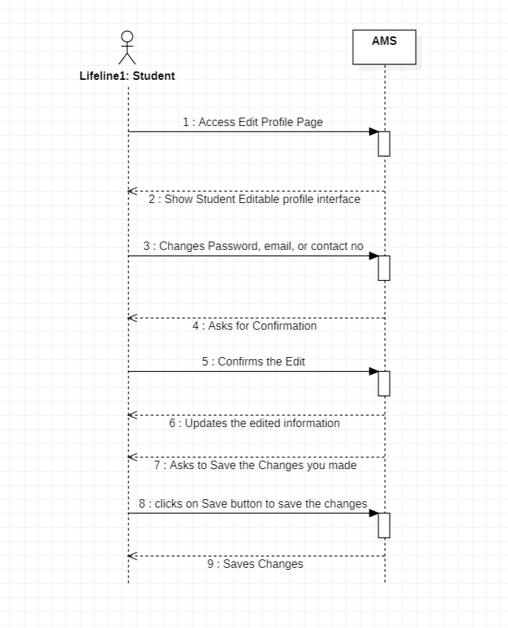

### Notify

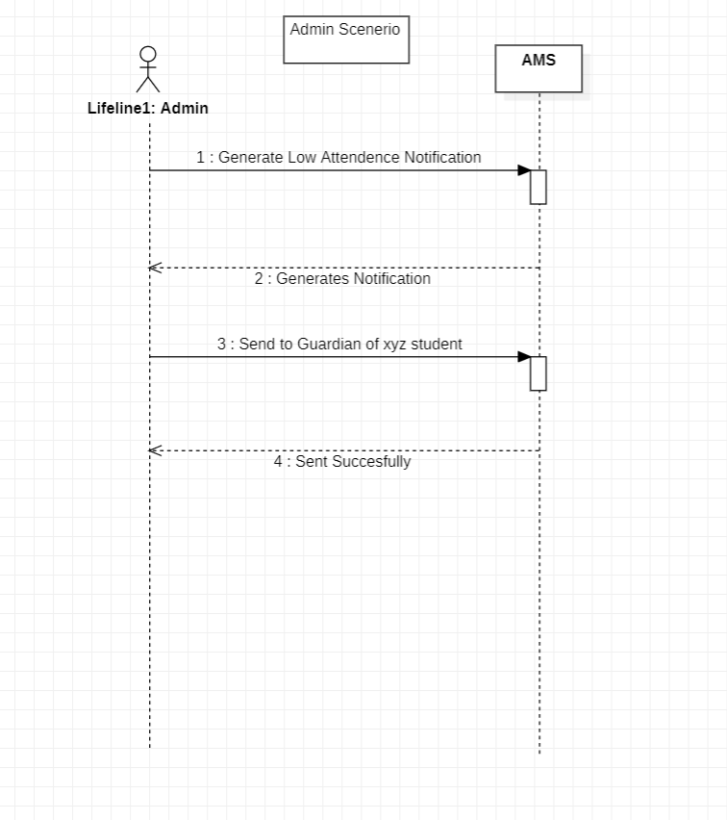

# Chapter 5 Operational Contract

## Shamsa Rani

### View Attendance

|  |  |
| --- | --- |
| operation | Select class (class ID, class Name, total students) |
| Cross reference | Use case: View attendance |
| Pre-condition’s | Teacher must be login to AMS (admission management system) and have selected view attendance module to view attendance of specific class. |
| Post-conditions | Teacher successfully selects the specific class. |

|  |  |
| --- | --- |
| operation | Select section (Sec name, sec id) |
| Cross reference | Use case: View attendance |
| Pre-condition’s | Teacher must have selected the view attendance option and select the specific class whom attendance they want to view and then user selected the specific section of that class whom attendance they want to view. |
| Post-conditions | Teacher successfully viewed the attendance of specifically selected class. |

|  |  |
| --- | --- |
| operation | Display Attendance (Total students, attendance status, total presents, total absents) |
| Cross reference | Use case: View attendance |
| Pre-condition’s | Teacher must have selected the view attendance option and select the specific section of that class. |
| Post-conditions | System successfully shows the attendance of that selected class and teacher view it. |

### Communicate with teacher

|  |  |
| --- | --- |
| operation | Display option (Option name, total options) |
| Cross reference | Use case: communicate with teacher |
| Pre-condition’s | Guardian has verified credentials and login to AMS and wants to communicate with teacher so guardian selects the contact option. |
| Post-conditions | When user clicked contact option system displays different option to user to make contact with teacher. |

|  |  |
| --- | --- |
| operation | Choose options (Option id, option name,) |
| Cross reference | Use case: communicate with teacher |
| Pre-condition’s | Guardian must have login to AMS system and had selected this module to contact with teacher system displays different options to user by which guardian can easily contact with teacher. |
| Post-conditions | User successfully chooses options for contacting teacher. |

|  |  |
| --- | --- |
| operation | Teacher response (Response id) |
| Cross reference | Use case: communicate with teacher |
| Pre-condition’s | Teacher must have selected the view attendance option and select options for contacting teacher. And successfully send message or made contact. |
| Post-conditions | Teacher successfully responses to the message of guardian. |

|  |  |
| --- | --- |
| operation | Show response to guardian |
| Cross reference | Use case: communicate with teacher |
| Pre-condition’s | Teacher must have selected the view attendance option and select the specific class whom attendance they want to view and then teacher selected the specific section of that class and had selected the option to contact with teacher. Guardian had successfully made contact with teacher by DM or email etc. |
| Post-conditions | Teacher receives the message of guardian and shows their response back to guardian. |

### Update Information

|  |  |
| --- | --- |
| operation | Select update info (Information name, info id, info type) |
| Cross reference | Use case: update information |
| Pre-condition’s | In order to update their personal info or if admin wants to change others information, they must have selected update information option. |
| Post-conditions | User successfully selected update option and system shows their information whom they want to change. |

|  |  |
| --- | --- |
| operation | Update information (Info id, info name) |
| Cross reference | Use case: update information |
| Pre-condition’s | User must have chosen the update info option and change their personal or other information. |
| Post-conditions | User successfully changed or updates others or their personal information. |

|  |  |
| --- | --- |
| operation | Saves info |
| Cross reference | Use case: update information |
| Pre-condition’s | User had chosen update info option and changed or update their information. |
| Post-conditions | System successfully saved new information and update it. |

## Shahzaib

### Mark Attendance

|  |  |
| --- | --- |
| Operation | Select Class (Class ID, Class Name, Students) |
| Cross reference | Use Case: Mark Attendance |
| Pre-condition | Teacher must be login the AMS (Attendance Management System) and Select the Mark Attendance module to mark attendance of selected class |
| Post Condition | Teacher successfully marks the specific class attendance |

|  |  |
| --- | --- |
| Operation | Select Section (Section name, section id) |
| Cross reference | Use Case: Mark Attendance |
| Pre-condition | Teacher must have selected the mark attendance option and select the specific class whom attendance they want to mark and then teacher selected the specific section of that class whom attendance they want to mark. |
| Post Condition | Teacher successfully marks the attendance of specifically selected class. |

### Search Student

|  |  |
| --- | --- |
| Operation | Select Class (Class ID, Class Name, Students) |
| Cross reference | Use Case: Search Student |
| Pre-condition | Teacher must be login the AMS (Attendance Management System) and Select the Search Student module to search student from selected class |
| Post Condition | Teacher successfully searches the student from specifically selected class. |

|  |  |
| --- | --- |
| Operation | Select Section (Section name, section id) |
| Cross reference | Use Case: Search Student |
| Pre-condition | Teacher must have selected the search student option and select the specific class from which they want to search the student and then teacher selected the specific section of that class whom student they want to search. |
| Post Condition | Teacher successfully searches student from specifically selected class |

### Check Attendance

|  |  |
| --- | --- |
| Operation | Select Class (Class ID, Class Name, Students) |
| Cross reference | Use case: Check Attendance |
| Pre-condition | Teacher must be login the AMS (Attendance Management System) and Select the Check Attendance module to check attendance of selected class |
| Post Condition | Teacher successfully checks the attendance of specifically selected class. |

|  |  |
| --- | --- |
| Operation | Select Section (Section name, section id) |
| Cross reference | Use case: Check Attendance |
| Pre-condition | Teacher must have selected the check attendance option and select the specific class from which they want to check the attendance and then teacher selected the specific section of that class whom they want to check attendance. |
| Post Condition | Teacher successfully checks attendance of specifically selected class |

### Check class

|  |  |
| --- | --- |
| Operation | Select slot (Class Time, Class Date) |
| Cross reference | Use case: Check Class |
| Pre-condition | Teacher must be login the AMS (Attendance Management System) and Select the Check class module to check class from selected slot |
| Post Condition | Teacher successfully checks the class from specifically selected slot. |

|  |  |
| --- | --- |
| Operation | Select slot (Class Time, Class Date) |
| Cross reference | Use case: Check Class |
| Pre-condition | Teacher must have selected the check class option and select the specific class from slot and then teacher selected the specific section of that class whom they want to check. |
| Post Condition | Teacher successfully checks class of specifically selected slot |

# Aqsa (FA21-BSE-079)

|  |  |
| --- | --- |
| **operation** | Enter Credentials  (Username/Email, Password) |
| **Cross reference** | Use case: Login |
| **Pre-condition’s** | User will enter his accurate email or username and password on the given space. |
| **Post-conditions** | User clicks on Login button. |
|  | |

### LOGIN

|  |  |
| --- | --- |
| **operation** | Validates Credentials  (Correct Username/Password or Incorrect) |
| **Cross reference** | Use case: Login |
| **Pre-condition’s** | AMS will validate if the given credentials match the user data. |
| **Post-conditions** | The Given credentials are successfully validated by AMS. |

|  |  |
| --- | --- |
| **operation** | Click on Login Button |
| **Cross reference** | Use case: Login |
| **Pre-condition’s** | After successful validation, User will now click on Login Button to Access the Main Menu Page. |
| **Post-conditions** | User Clicks the Login button. |

|  |  |
| --- | --- |
| **operation** | Incorrect Credentials  (Username/Email, Password) |
| **Cross reference** | Use case: Login |
| **Pre-condition’s** | System declined user request to Login because of incorrect input of Email or Password. System will Ask the user to Again try to Login with Correct credentials this time. |
| **Post-conditions** | User will re-type his credentials. |

### NOTIFY

|  |  |
| --- | --- |
| **operation** | Admin Commands to Generate a Notification  (Admin to System) |
| **Cross reference** | Use case: Notify |
| **Pre-condition’s** | If any student’s attendance is below 80%, Admin will command the system to generate a Notification. |
| **Post-conditions** | System received the command to generate a Notification. |

|  |  |
| --- | --- |
| **operation** | AMS generates Notification |
| **Cross reference** | Use case: Notify |
| **Pre-condition’s** | AMS receives the command from admin and generates the notification. |
| **Post-conditions** | AMS has Generated the Notification. |

|  |  |
| --- | --- |
| **operation** | Admin Commands the AMS to Send the Notification |
| **Cross reference** | Use case: Notify |
| **Pre-condition’s** | AMS has generated the Notification. Now the Admin Commands the system to Send this notification to the guardians of relevant student. |
| **Post-conditions** | AMS receives Send command from Admin. |

|  |  |
| --- | --- |
| **operation** | AMS Sends the Notification |
| **Cross reference** | Use case: Notify |
| **Pre-condition’s** | AMS receives the command from admin of sending the notification. |
| **Post-conditions** | AMS sends the notification to the Guardians. |

### Edit Profile

|  |  |
| --- | --- |
| **operation** | User Wants to Edit his Profile |
| **Cross reference** | Use case: Edit Profile |
| **Pre-condition’s** | User wants to change his contact, email or password. |
| **Post-conditions** | User clicks on Edit profile option. |

|  |  |
| --- | --- |
| **operation** | Edit Profile Interface |
| **Cross reference** | Use case: Edit Profile |
| **Pre-condition’s** | User has clicked on the Edit profile option. |
| **Post-conditions** | An edit profile interface of AMS has displayed. |

|  |  |
| --- | --- |
| **operation** | Edits/ Changes Personal Info |
| **Cross reference** | Use case: Edit Profile |
| **Pre-condition’s** | User changes his Contact, Password or Email provided. |
| **Post-conditions** | User re-enters the new data in the desired option. |

|  |  |
| --- | --- |
| **operation** | Confirmation |
| **Cross reference** | Use case: Edit Profile |
| **Pre-condition’s** | User has given the new updated data, to the AMS. |
| **Post-conditions** | AMS asks for confirmation. |

|  |  |
| --- | --- |
| **operation** | User Confirms. |
| **Cross reference** | Use case: Edit Profile |
| **Pre-condition’s** | User clicks on confirm the changes. |
| **Post-conditions** | Changes are confirmed. |

|  |  |
| --- | --- |
| **operation** | AMS updates the new data |
| **Cross reference** | Use case: Edit Profile |
| **Pre-condition’s** | AMS receives new updated data from the user. |
| **Post-conditions** | AMS updates the data of the user. |

|  |  |
| --- | --- |
| **operation** | Save Changes |
| **Cross reference** | Use case: Edit Profile |
| **Pre-condition’s** | Now final step is to Save the changes that has been made in the user data, by the user. |
| **Post-conditions** | AMS asks the user to Save the Changes Made. |

|  |  |
| --- | --- |
| **operation** | User Saves the Changes |
| **Cross reference** | Use case: Edit Profile |
| **Pre-condition’s** | User has been asked by the AMS to Save the Changes. |
| **Post-conditions** | User Clicks on SAVE CHANGES. |

|  |  |
| --- | --- |
| **operation** | AMS Saves the New Data into the system. |
| **Cross reference** | Use case: Edit Profile |
| **Pre-condition’s** | User saves the updated data. |
| **Post-conditions** | AMS Saves Changes. |

# Ahsan Zeb (FA21-BSE-071)

### Logout

|  |  |
| --- | --- |
| **operation** | Click logout button |
| **Cross reference** | Use case: Logout |
| **Pre-condition’s** | User must be login to AMS (admission management system) and have clicked on the logout button to get logged out of the system. |
| **Post-conditions** | The user is logged out of the system and no longer has access to any protected functionality. |

### Generate Discipline Report

|  |  |
| --- | --- |
| **operation** | Search student (Std name, std reg#) |
| **Cross reference** | Use case: generate discipline report |
| **Pre-condition’s** | User must have selected the generate discipline report option and select the specific student whose discipline report is to be generated. |
| **Post-conditions** | User successfully searched the student whose report is to be generated. |

|  |  |
| --- | --- |
| **operation** | Select report type |
| **Cross reference** | Use case: generate discipline report |
| **Pre-condition’s** | User must have specified the type of report they want to generate for a student. |
| **Post-conditions** | The user has successfully selected a report type. |

|  |  |
| --- | --- |
| **operation** | Select report data |
| **Cross reference** | Use case: generate discipline report |
| **Pre-condition’s** | Guardian must have login to AMS system and had selected the data from which the report is to be extracted. |
| **Post-conditions** | User successfully selects the data from which the report is to be generated. |

|  |  |
| --- | --- |
| **operation** | Generate report |
| **Cross reference** | Use case: generate discipline report |
| **Pre-condition’s** | * The user must be authenticated and authorized to generate discipline reports. * The necessary data for generating the report must be available in the system. |
| **Post-conditions** | A discipline report is generated and provided to the user or stored in the system. |

### Manage settings

|  |  |
| --- | --- |
| **operation** | Select manage settings |
| **Cross reference** | Use case: manage settings |
| **Pre-condition’s** | * The user must be logged in to the system. * The user must be authenticated and authorized to manage system settings. * The system must have the necessary permissions and resources to allow the user to modify the settings |
| **Post-conditions** | User have successfully selected manage settings and system shows their previous settings whom they want to change. |

|  |  |
| --- | --- |
| **operation** | Modify existing settings |
| **Cross reference** | Use case: manage settings |
| **Pre-condition’s** | User must have chosen the modify settings option and change their existing settings. |
| **Post-conditions** | User successfully changed or modified their existing settings. |

|  |  |
| --- | --- |
| **operation** | Saves new settings |
| **Cross reference** | Use case: manage settings |
| **Pre-condition’s** | User had chosen modify settings option and changed or update their existing settings. |
| **Post-conditions** | System successfully saved new settings and update it. |

# CHAPTER: 6

## PACKAGE DIAGRAM

